## 

**AKNOWLEDGMENT**

The satisfaction and euphoria that accompany the successful completion of any task would be incomplete without mentioning the people who have made it possible, because success is the epitome of hard work. So with gratitude, we acknowledge all those whose guidance and encouragement have made our efforts successful in this group.

We wish to express our deep sense of gratitude to our lecture **L S. A Mgungo** from the Department of Mechanical Engineering for his encouragement, which went a long way in the successful completion of this project.

We thank to every individual who has directly or indirectly influenced us to propel the project to its completion.

# ABSTRACT

The aim of this project is to design a gearbox that is compact, lightweight and has extended life. Major fields covered are Material selection, Machine Engineering Design of Gears, Shafts, Gearbox Casing, Bearing selection, Vibrations caused due to the Engine. The design is also finalized with the fits required for assembly and the final product is expected to be efficient, light weight, compact and long lasting.

After several calculations and assumptions depending on the type of the material and safety operations the two stage gear type of shafts diameters of 25mm, 30mm, 35mm, and Diameter of the two gears are 72mm and 144mm, face width 50mm, module 4mm, center distance 108mm, pitch 12.57mm, addendum 4mm, dedendum 5mm, working depth 9mm were selected.

Keyways dimensions of length 25mm width 8mm and height 7mm. Housing dimensions of 96x144x180. Bearing outer diameter is Ø52mm.

# TABLE OF CONTENT

[TABLE OF FIGURES](#_TOC_250046)

[SIGNIFICANCE OF THE REPORT 1](#_TOC_250041)

[SCOPE OF THE REPORT 1](#_TOC_250040)

[LITERATURE REVIEW 2](#_TOC_250039)

[THE GEAR BOX 2](#_TOC_250038)

[REDUCTION GEARBOX 2](#_TOC_250037)

[Types of Reduction Gearbox 2](#_TOC_250036)

[COMPONENTS OF A GEARBOX 3](#_TOC_250035)

[Casing 3](#_TOC_250034)

[Gears 3](#_TOC_250033)

[Gear Types 3](#_TOC_250032)

[Shafts 4](#_TOC_250031)

[Bearings 5](#_TOC_250030)

[METHODOLOGY 6](#_TOC_250029)

[DESIGN OF TWO STAGE SPEED REDUCER GEAR BOX 8](#_TOC_250028)

[DESIGNING OF GEARS 8](#_TOC_250027)

[DESIGN OF FIRST STAGE REDUCTION 8](#_TOC_250026)

[Torque 9](#_TOC_250025)

[Shaft Diameter 9](#_TOC_250024)

[Number of Teeth 10](#_TOC_250023)

[Pinion and Gear Diameters 10](#_TOC_250022)

[Center distance (a) 11](#_TOC_250021)

Face width (b) 11

[Circular pitch (Pc) 11](#_TOC_250020)

[Addendum and Dedendum 11](#_TOC_250019)

[Working depth (hk) 11](#_TOC_250018)

[Whole depth (ht) 12](#_TOC_250017)

Maximum Clearance (C1) 12

[Diametral pitch (P) 12](#_TOC_250016)

[Outside Diameters 12](#_TOC_250015)

[Filet radius (rf) 12](#_TOC_250014)

[Pitch Velocity (v) 12](#_TOC_250013)

[Sliding velocity (vs) 13](#_TOC_250012)

[Gear Forces 13](#_TOC_250011)

[GEAR STRESSES 14](#_TOC_250010)

[Bending Strength 14](#_TOC_250009)

[Fatigue Strength 14](#_TOC_250008)

[Key design 16](#_TOC_250007)

[Bearings 16](#_TOC_250006)

[SEALS FOR GEAR BOX 17](#_TOC_250005)

[Seal life 17](#_TOC_250004)

[DESIGN OF THE SECOND STAGE GEAR REDUCTION 17](#_TOC_250003)

[CONCLUSION 19](#_TOC_250002)

[REFERENCES 20](#_TOC_250001)

# LIST OF SYMBOLS

α -Pressure Angle

a -Centre Distance

B -Face width

Cv -Velocity Factor d -Pitch diameter

d1 -Pitch diameter of pinion d2 -Pitch diameter of gear E -Young’s Modulus

Fs -Strength of Gear tooth Ft -Transmitted Load

i -Gear Ratio

K -Load Concentration Factor Kd -Dynamic load factor M -Module

Mt -Torque Transmitted by Pinion Pc-Circular Pitch Q -Ratio Factor

σc -Contact Stress

σb -Designed Bending Stress vm -Mean Velocity

y -Lewis Form Factor

Z -Number of teeth

Z1 -Number of teeth Pinion Z2 -Number of teeth Gear

Se -Endurance limit of the gear tooth Ka - Surface Factor

Kb -Size factor

Kc - Reliability Factor Kd -Temperature Factor

Ke -Modifying factor for Stress concentration Kf -Miscellaneous-effect

S , -Endurance limit of rotating-beam specimen n -Factor of Safety

e

# INTRODUCTION

## PROBLEM STATEMENT

Designing a two-stage reduction gearbox using spur gears, with a single output speed. The output shaft is to be in line with the input shaft.

## OBJECTIVES

The main objectives of the report involve the pair of double helical Gear Designing, Shaft Designing, Key designing, Housing Designing, Bearing selection and Seals for Gearbox.

## SIGNIFICANCE OF THE REPORT

To ensure use of proper materials for each component of the gearbox. The design is done prior to manufacture and includes calculations of gear geometry taking into account gear strength, material selection, gear alignment and provisional for gear lubrication.

## SCOPE OF THE REPORT

The report is to be based on two stage gear system. This system is formed by three shafts connected to each other by two pairs of spur gears. The system can be used to reduce the gear speed thus increasing the torque available, change the direction of power transmission and distribute the available power between systems.

# LITERATURE REVIEW

## THE GEAR BOX

A Gearbox is a device that used for transmitting power from the Power source to the output shaft. A gearbox has a set of gears that are enclosed in a casing. The gears are mounted on shafts which rotate freely about their axis. The gears are fixed on the shafts by Fits or by a key. These shafts are made to rotate freely on a support called casing. Bearings are tightly fit between the shafts and the casing. Today’s cars have various sets of gears which give different speeds and torque on different Gears.

A Gearbox is necessary because it is impractical to directly connect the input source to the output shaft. The power source may not have enough torque to bear the whole load at once. This will put a load on the power source which may cause overheating, more fuel consumption or even failure of the components. Gearbox gives leverage to the power source by enhancing the torque at initial gears and then delivering high speeds at final stages. This reduces the capacity of the power source required and hence less fuel consumption. Each Gearbox has its own set of Gear ratios that can be selected by the driver or just one set of universal Gear Ratio that will work with the help of a Torque converter or Continuously Variable Transmission Major components include gears, Casing, Shafts, and Bearing.

## REDUCTION GEARBOX

A reduction gearbox is a device by which an input speed can be lowered for a requirement of slower output speed, with same or more output torque. Reduction gear assembly consists of a set of rotating gears connected to an output shaft. The high speed incoming motion from the wheel work is transmitted to the set of rotating gears, wherein the motion or torque is changed. The number of gears used in the reduction gear assembly depends on the output speed requirement of the application. The reduction gear assembly is usually known as reduction gear box. Depending on the Output speed required, the reduction may have single stage or two stage reduction.

## Types of Reduction Gearbox

There are mainly two types of reduction gears:

* Single reduction gear
* Double reduction gear

## Single Reduction Gear

This arrangement consists of only one pair of gears. The reduction gear box consists of ports through which the propeller shaft and engine shaft enters the assembly. A small gear known as a pinion is driven by the incoming engine shaft. The pinion directly drives a large gear mounted on the propeller shaft. The speed is adjusted by making the ratio of the speed reduction to the diameter of pinion and gear proportional. Generally, a single gear assembly has a gear double the size of a pinion.

## Double Reduction gear

Double reduction gears are generally used in applications involving very high speeds. In this arrangement the pinion is connected to the input shaft using a flexible coupling. The pinion is connected to an intermediate gear known as the first reduction gear.

The first reduction gear is then connected to a low speed pinion with the help of one more shaft. This pinion is connected to the second reduction gear mounted directly on the propeller shaft.

## COMPONENTS OF A GEARBOX

A Gearbox comprises of major components namely:

* + Housing
  + Gears
  + Shafts
  + Bearings.

## Gears

A gear is a rotating machine part having cut teeth, which mesh with another toothed part to transmit torque. Geared devices can change the speed, torque, and direction of a power source. Gears almost always produce a change in torque, creating a mechanical advantage, through their ratio. The teeth on the two meshing gears all have the same shape. Two or more meshing gears, working in a sequence, are called a gear train or a transmission

Helical Gear

Helical gears operate more smoothly and quietly compared to spur gears due to the way the teeth interact. The teeth on a helical gear cut at an angle to the face of the gear. When two of the teeth start to engage, the contact is gradual--starting at one end of the tooth and maintaining contact as the gear rotates into full engagement. The typical range of the helix angle is about 15 to 30 deg. The thrust load varies directly with the magnitude of tangent of helix angle. Helical is the most commonly used gear in transmissions.

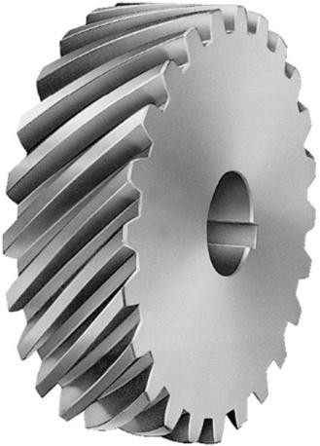

**Figure 2: HELICAL GEAR**

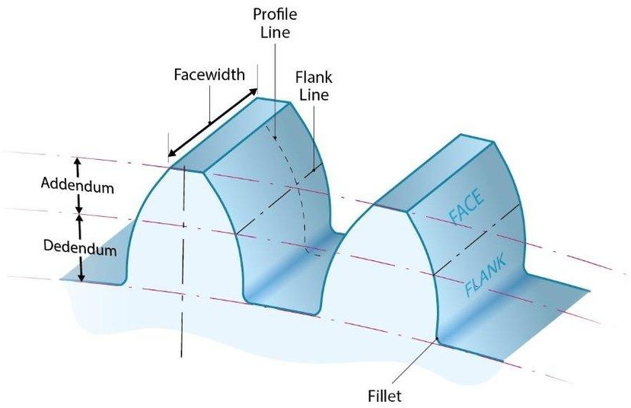Key Terms on gears

**Figure 3: GEAR TOOTH GEOMETRY**

## Shafts

A shaft is a rotating machine element which is used to transmit power from one place to another. The power is delivered to the shaft by some tangential force and the resultant torque (or twisting moment) set up within the shaft permits the power to be transferred to various machines linked up to the shaft. In order to transfer the power from one shaft to another, the various members such as pulleys, gears etc., are mounted on it.

## Bearings

Bearing is a component that ensures smooth rotation between the fixed support and the rotating shafts. These components are made of high carbon alloy steels that can bear huge amount of loads and rotate at high RPMs/There are two types of bearing--- Sliding contact bearing and rolling contact bearings. Sliding contact have a fluid between the inner and outer race that ensures smooth rotation. Rolling contact bearings also known as ball bearings have a handful of tiny hardened steel balls or rollers between the inner and outer race, these balls are super finished and have less friction compared to the sliding contact bearings.

These bearing have two types of loads acting on them namely Radial and Axial loads. These loads are calculated while making the gearbox. The outer race of the bearing is fitted into the casing and the inner race to the shaft.

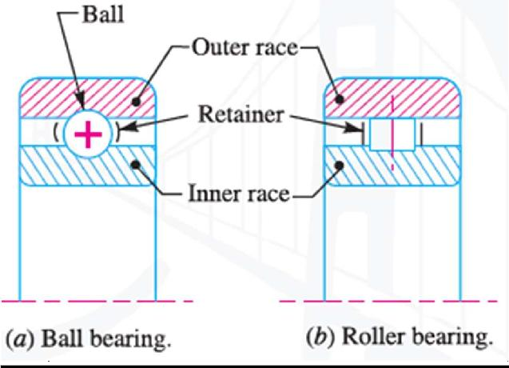

## METHODOLOGY 3.1 SHAFT DESIGN FORMULA Shaft diameter, D D3= 16/π X T X 1/τ and D3= 16/π X T X 1/ σ T=P/ώ, ώ=2 πN/60, τ (shear stress) = 42 N/mm2 (Mild Steel), σ (bending stress) = 84 N/mm 3.2 GEAR DESIGN FORMULA Velocity ratio, i=Z2/Z1=N1/N2 Gear Diameters (d); d=m Z For pinion, d1=mZ1 For gear, d2=mZ2 Centre distance, C=1/2 x (d1+d2) Pitch Velocity, V = (m Z ώ)/2 Sliding Velocity, Vs = JK (ώ1+ ώ2) Where JK=Path of recess JK = [1/2(d2+a)2 - 1/2(d2cosØ)2]1/2 -1/2d2sinØ + ……+[1/2(d1+a)2 - 1/2(d1cosØ)2]1/2 -1/2d1sinØ Circular Pitch, P = πm Addendum, a=module, m Dedendum, b=1.25m Working Depth, hk=2m Whole depth, ht=a+b Tooth thickness, t = (πm)/2 Tooth width, w=4πm Maximum Clearance, c=0.25m Outside Diameter, d0 d0 = (Z1+2)/p, p-diametral pitch Diametral pitch, p=z/d, p=z1/d1=z2/d2 12 Pinion outside diameter, d01 = (z1+2)/p Gear outside diameter, d02 = (z2+2)/p Fillet diameter, rf = 0.3m Gear Forces Tangential Force, Ft=T/r1, T- Torque transmitted. R1- radius of driver. Radial forces, Fr = Ft x tan Ø Normal Force, Fn =√ (Ft2+Fr2) Gear Stresses Lewis Bending Stress Equation, σ = Ft / (w P y) w- Face width P- Circular Pitch y- Lewis Factor Fatigue Strength The endurance strength is given by: Se= Ka.Kb.Kc.Kd.ke.Kf.Se’ Where: Se - endurance limit of gear teeth Se’- endurance limit of rotating beam specimen Ka - Surface factor Kb -Size factor Kc - Reliability factor Ke - Modifying factor for stress concentration Kf -miscellaneous effect factor Factor of safety, Ks; 13 Ks = Ko.Km n, and Ks = Se/σ Where: σ = Ft / (Kv. W m J) And: Kv = [78 / (78 + (200v) 1/2)] 1/2 For high precision, sheared or ground teeth with appreciable dynamic load

## DESIGN OF TWO STAGE SPEED REDUCER GEAR BOX

## DESIGNING OF GEARS

The first criteria in designing the gears are to keep them simple, less weight and at the same time to keep the cost as low as possible. So, the weight and cost have their respective weight during the design such that both the parameters could be worth enough.

The machinability is another important consideration.

**Type of gear used:** Helical Gear with full depth involute teeth.

## DESIGNING OF GEARS

The first criteria in designing the gears are to keep them simple, less weight and at the same time to keep the cost as low as possible. So, the weight and cost have their respective weight during the design such that both the parameters could be worth enough.

The machinability is another important consideration.

**Type of gear used:** Spur Gear with full depth involute teeth.

The following the parameters required to obtain the required gear profile.

* Module
* Number of teeth
* Addendum
* Dedendum
* Working depth
* Gear pitch
* Tooth thickness
* Fillet radius
* Centre Distance
* Clearance
* Face width

**FIRST STAGE REDUCTION(Helical Gear)**

Overall gear ratio, i = 4

Input power = 3.73kW

Input Speed, N1 = 2000rpm

Pressure Angle, θ = 200 and helix angle α=30

**1.GEAR GEOMETRY**

From

catalogues module selected is 2mm

**I. Number of teeth**

For pinion gear Z1

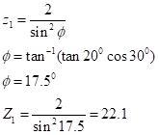

Then we take Z1=24 since Z1≥22.1

For Driven gear Z2



**ii. Addendum a**

addendum = m hence a=2mm

**iii. Dedendum de**

dedendum = 1.25m hence de =2.5mm

**iv. Working depth**=de+a

hence 2.5+2=4.5mm

**v.Gear pitch**

p=πm

=6.28mm

**vi.Tooth thickness**

=πm/2

=3.14mm

**vii.Face width**

=4πm

=25.01mm

Hence face width 26mm

**viii.Fillet radius**

=0.3m

0.3×2=0.6mm

**ix.Maximum clearance**

=0.25m

=0.25×2

=0.5mm

**x.Pitch diameter**

For pinion



Hence diameter will be 56mm

For Driven



Hence diameter will be 111mm

**xi.Centre distance**



Hence centre distance will be 84mm

**xii.Outer diameter**

For pinion



Hence diameter will be 60mm

For Driven



Hence the diameter will be 116mm

**xiii.Transverse module**



**2.GEAR PATHS**

**i.Path of recess**



**ii.Path of Approach**



**iii.Path of contact**



**3.GEAR VELOCITIES**

**i.Sliding velocity**



**ii.Pitch Velocity**



**4.GEAR FORCES**

**iTangential Force**



**ii.Radial Force**



**iii.Axial force**



**iv.Resultant force**



**5.GEAR STRENGTH AND STRESSESS**

**i.Bending strength**



From Catalogue lewis form factor Y=0.33056

Hence,



**ii.Indurance strength**

Fatique strength:  
The endurance strength is given by:  
Se= Ka.Kb.Kc.Kd.ke.Kf.Se’  
Se’=0.5 Sut  
For cast iron/steel, Sut=600Mpa, (from Design of machine element)  
Se’ = 0.5×600Mpa  
Se’ = 300N/mm2  
Ka=0.742, for m=mm, Kb=0.930  
For; 95% Reliability, Kc=0.868  
For T≤ 350°C, Kd = 1  
Kc=1, (known as a unity)  
For Sut ≤ 1400Mpa  
Kf=1.33  
Se=0.742×0.930×0.868×1×1×1.33×30x106= 239Mpa  
= 239Mpa

**iii.Factor of safety**



Since; n≥2; According to AGMA, it is safe.

**SECOND STAGE REDUCTION(Spur Gear)**

Overall gear ratio, i = 4

Input power = 3.73kW

Input Speed, N2 = 1000rpm

Pressure Angle, θ = 200

**1.GEAR GEOMETRY**

From

catalogues module selected is 2mm

**i.Number of teeth**

For pinion gear Z1



Hence take Z1=30Teeth

i=Z2/Z1

Also Z2=60 teeth

**ii.Addendum a**

addendum = m hence a=2mm

**iii.Dedendum de**

dedendum = 1.25m hence de =2.5mm

**iv.Working depth**=de+a

hence 2.5+2=4.5mm

**v.Gear pitch**

p=πm

=6.28mm

**vi.Tooth thickness**

=πm/2

=3.14mm

**vii.Face width**

=4πm

=25.01mm

Hence face width 26mm

**viii.Fillet radius**

=0.3m

0.3×2=0.6mm

**ix.Maximum clearance**

=0.25m

=0.25×2

=0.5mm

**x.Pitch diameter**

For pinion



Diameter will be 60mm

For Driven



Hence diameter will be 120mm

**xi.Centre distance**

mm

Hence centre distance will be 90mm

**xii.Outer diameter**

For pinion



Hence diameter will be 64mm

For Driven



Hence the diameter will be 124mm

**2.GEAR PATHS**

1. **Path of recess**



**ii.Path of Approach**



**iii.Path of contact**



**3.GEAR VELOCITIES**

**i.Sliding velocity**



**ii.Pitch Velocity**



**4.GEAR FORCES**

**iTangential Force**



**ii.Radial Force**



**iii.Axial force**



**iv.Resultant force**



**5.GEAR STRENGTH AND STRESSESS**

**i.Bending strength**



From Catalogue lewis form factor Y=0.35510

Hence,



**ii.Indurance strength**

Fatique strength:  
The endurance strength is given by:  
Se= Ka.Kb.Kc.Kd.ke.Kf.Se’  
Se’=0.5 Sut  
For cast iron/steel, Sut=600Mpa, (from Design of machine element)  
Se’ = 0.5×600Mpa  
Se’ = 300N/mm2  
Ka=0.742, for m=mm, Kb=0.930  
For; 95% Reliability, Kc=0.868  
For T≤ 350°C, Kd = 1  
Kc=1, (known as a unity)  
For Sut ≤ 1400Mpa  
Kf=1.33  
Se=0.742×0.930×0.868×1×1×1.33×30x106= 239Mpa  
= 239Mpa

**iii.Factor of safety**



Since; n≥2; According to AGMA, it is safe.

**2.DESIGNING OF SHAFT,BEARING AND KEYBARS**

**2.1 SHAFT DESIGN**

## 

## 

## 

## Torque

Power = Torque× Angular Speed1

1

3730

T1

209.44

Also,

T1 =17.81 **Nm**





There Fore,

Transmitted Torque, T1 = 17.81Nm

Counter shaft Torque,T2 = 35.62Nm

Output shaft torque =71.24Nm

## Input Shaft Diameter

Material Selected for the shaft is Mild Steel with,

Shear Stress,=

Diameter of input shaft



Pinion Shaft diameter, D = 15mm

Length of shaft, Ls =bw+2i +w  
=11+4+26

=41mm

Take Shaft length 90mm

**Counter Shaft Diameter**

For Shear Stress,



Diameter of counter shaft will be 20mm

Length of shaft, Ls =bw+2i +w  
=14+4+26

=44mm

Take Shaft length 180mm

**Diameter of output shaft**

For Shear Stress



,Diameter of output shaft will be 25mm

Length of shaft, Ls =bw+2i +w  
=15+4+26

=45mm

Take Shaft length 90mm

**2.2 KEYS DESGNING**

For Bending Stress, = 84MPa and Shear Stress, = 42MPa

The Length of the Key is given by the Face width. L= W = 26mm

From Roymech Standard Keys For shaft Diameter of 25mm key height, h = 7mm

key width, b = 8mm

A 7×8×50

For shaft Diameter of 20mm key height, h = 6mm

key width, b = 6mm

A 6×6×50

For shaft Diameter of 15mm key height, h = 5mm

key width, b = 5mm

A 5×5×50

## 2.3 BEARINGS SELECTION

For Input shaft Diameter, 15mm

For counter shaft Diameter, 20mm

For for output shaft Diameter, 25mm

BEARING SPECIFICATION

|  |  |  |  |  |
| --- | --- | --- | --- | --- |
| BEARING N0 | BORE (mm) | OUTSIDE DIAMETER (mm) | WIDTH (mm) | Type |
| 202 | 15 | 35 | 11 | Tapered roller bearing |
| 204 | 20 | 47 | 14 | Tapered roller bearing |
| 205 | 25 | 52 | 15 | Tapped roller bearing |

**3.GEAR BOX HOUSING**

Material: Cast iron  
Housing Dimension

Total length, L=ls+bw+(2×th)  
Ls-length of shaft  
bw- bearing width  
th- housing thickness wall  
L = 180+15+15+4  
L= 214mm  
5. Housing height; H= (d1/2+m)+(d2/2+m)+2s+2th  
= 184mm  
6. Housing width; w:  
W= (d2+2m) + 2(s+th)  
= (160+2×4) + 2(10+2)  
W=196mm  
Volume for housing; L×H×w=196×184×214  
= 7.72×106 mm cubic

**4.SEALS FOR GEAR BOX**Seals for gear box needs be of the following type  
⮚ Can be used at high speed and continuous shaft rotating  
⮚ Positive ability to resist pressure, temperature and shaft speed  
⮚ Tolerance of variety of lubrication conditions  
⮚ Relatively high intensity of dimension variations  
⮚ Low cost  
Seal life  
Long life for seal is 1000 operating hours. Medium life leakage begin at 400 hours to 600 hours  
of operation.

eal material  
Silicon: Good abrasion resistance  
Temperature range 27oc to 260oc  
Dimensions; φ

**5.LUBRICATION**

High viscosity provides thick oil film, high wear resistance and low galling even at high pressure (EP). Viscosity of a gear oil depends on the temperature, since this gear box is designed to operate ate relatively low temperatures.

Oil used is of viscosity: SAE 60

**CONCLUSION**Gearbox Designing is complete with all elements parameters obtained. There are four gears,three shafts, four keyways and keybars, housing, bearing and seals. The manufacturing stage can begin immediately after this report is submitted and approved.

**REFERENCES**

TheDesign of Machine Elements 6th edition1998 BY V.B.BHANDARY.

Internet (GOOGLE SCHOLAR).

Handbook of gear design by “Gitin M Maitra” 2nd edition. Machine Design by R S Khurmi by S Chand & company Ltd. Design Data book by Mc-Grawhill (2nd edition).

Patel, Mitesh, A. V. Patil, Mitesh Patel, and A. V. Patil. "Stress and Design Analysis of Triple Reduction Gearbox Casing." International Journal 2: 106-111.

Design basics of industrial gearbox by Andrzej Maciejczyk & Zbigniew Zdziennicki, Department of vehicles and fundamentals of machine design (technical university of Lodz).

Patnaik, Siddhartha. "DESIGN FAILURE MODES AND EFFECTS ANALYSIS (DFMEA) OF AN

ALL-TERRAIN VEHICLE." International Journal of Research in Engineering and Technology Design of Machine Elements 6th edition1998 BY V.B.BHANDARY.

Puttapaka Nagarju & Ch. Ashok Kumar (2014), “Modelling & analysis of 2- stage reduction gearbox”; IJMETMR; ISSN nobr-2348-4845, Volume No: 1 (2014); Issue No: 12 (December).

e analysis of contact stress on meshed teeth BY VERA, N.S. AND IVAN, C.

Lecture Notes on Shaft Design BY Dr. KIMORI YJ.

Machine Design Textbook BY Dr. SHARME AND Dr. D.K. Agorant.

# C:\Users\Omar\Desktop\New Doc 2019-07-10 20.04.46_1.jpgC:\Users\Omar\Desktop\New Doc 2019-07-10 03.01.53_1.jpgAPPENDIX

